**HOW TO PLAY??**

1. **Click on the start button.**

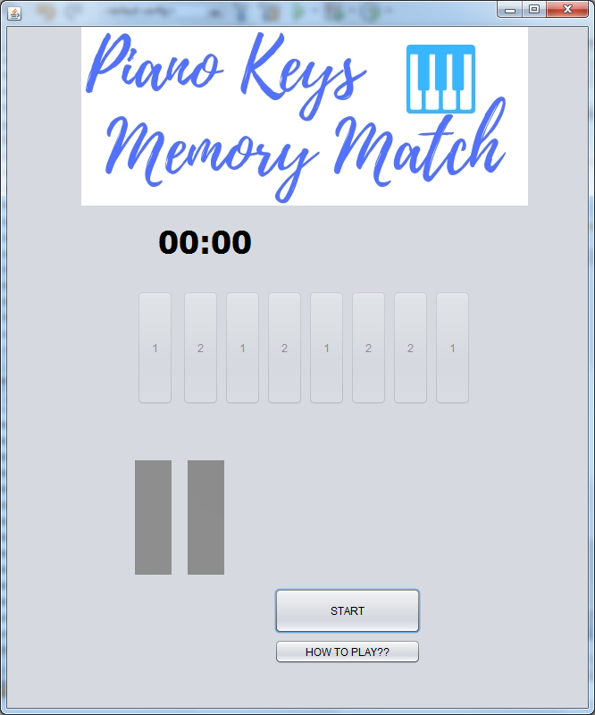

1. **10 seconds will be provided to remember the sequence of red amd green colour combination.**

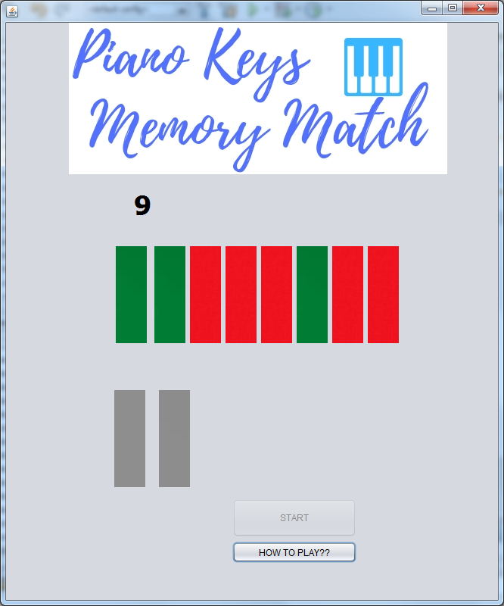

1. **After 10 sec red and green button will appear.**
2. **Click on them to match with the previous order or red and green buttons.**

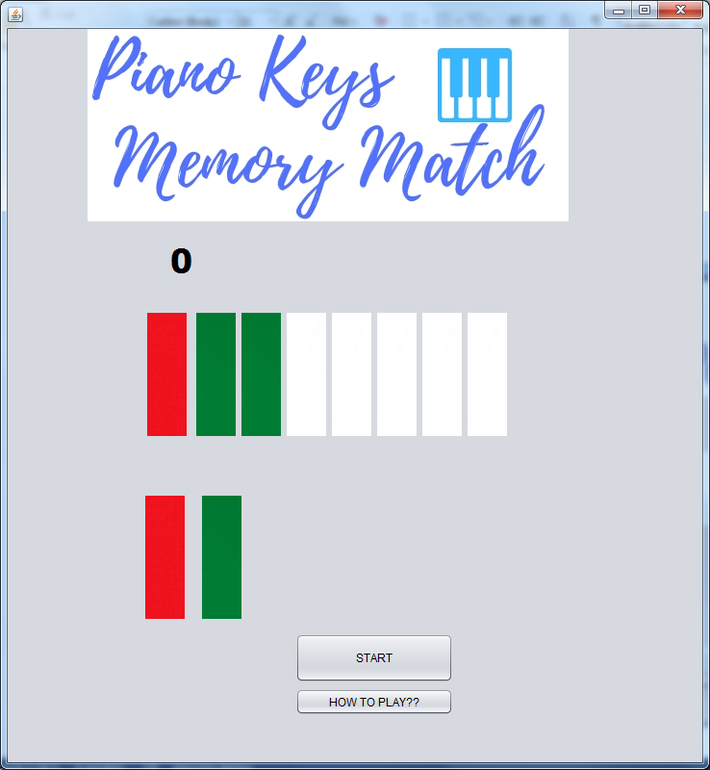

**ENJOY!!!^_^**